FOR IMMEDIATE RELEASE
JFK AIRPORT’S TERMINAL 4 OPERATOR DONATES OVER 100 TURKEYS TO JAMAICA COMMUNITY CHURCH

JFKIAT donated more than 100 turkeys and canned goods ahead of Thanksgiving

Queens, New York – November 26 – JFKIAT, the operator of Terminal 4 at John F. Kennedy International Airport, donated over 100 turkeys and canned goods to Bethany Baptist Church of Jamaica ahead of Thanksgiving, helping people in the local community enjoy homecooked meals during the holiday.
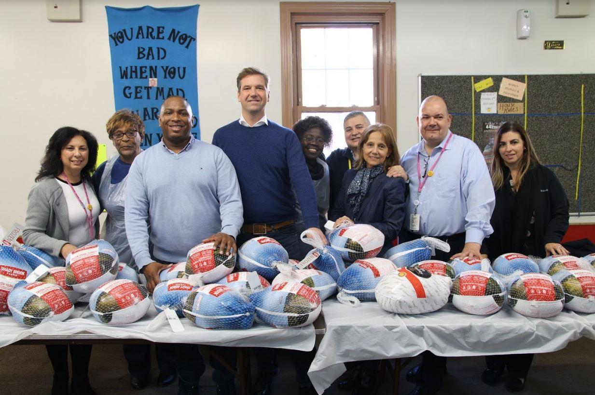
JFKIAT senior team members including CEO and President Roel Huinink with Bethany Baptist Church members at the turkey donation.
“JFKIAT is proud to help provide Bethany Baptist Church with food for those in need this Thanksgiving,” said Roel Huinink, JFKIAT President and CEO. “As a company operating within Queens, JFKIAT’s goal is to make a positive impact on our local community and working with vital organizations like Bethany Baptist Church is just one way that we seek to support our neighbors in Jamaica. We look forward to growing our relationship with the wonderful leaders of this church in the future.”
“Bethany Baptist Church is grateful for JFKIAT’s generous donation to our food pantry,” said Deacon Waters of Bethany Baptist Church. “We are happy that families in our community will be able to begin the holiday season with a warm meal and we appreciate JFKIAT’s contributions to make this happen.”
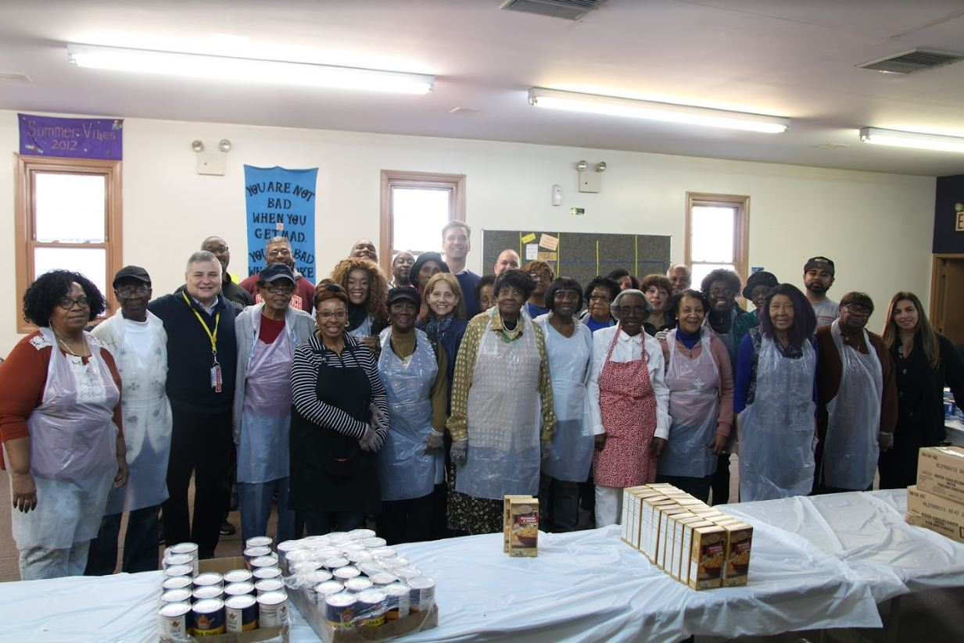
JFKIAT executives with Bethany Baptist Church members at the turkey donation.
JFKIAT’s corporate giving program, 4GOOD, seeks to serve local institutions through philanthropic and sustainable actions to make a positive impact on the community. Aimed at promoting educational, social, and professional success, the 4GOOD program consists of two components: Community (Corporate Philanthropy) and Sustainability (Environment). Corporate resources include financial contributions, charitable giving, employee volunteering and community outreach.
About JFKIAT
JFK International Air Terminal, LLC. (JFKIAT) is the operator of Terminal 4 at John F. Kennedy International Airport, one of the most active air terminals in the New York area, serving 34 international and domestic airlines with an annual passenger volume of more than 21 million travelers in 2018. Terminal 4 is the first existing airport terminal in the U.S. to receive LEED Gold certification by the United States Green Building Council (USGBC) for operations and maintenance. The Terminal’s expansive Retail Lounge offers an unparalleled experience for travelers with a wide range of food and beverage and retail options, from chic to upscale and from convenience stores, to electronics, accessories and gifts. Terminal 4 was the first air terminal in North America operated by a private management company. JFKIAT’s managing member is Schiphol USA Inc., a U.S. affiliate of Royal Schiphol Group.
Visit us at http://www.jfkt4.nyc, like us on Facebook and follow us on Instagram and Twitter.
# # #

Contact: Patrice Kugler
JFKIAT
(212) 402-3486
pkugler@marinopr.com

