FOR IMMEDIATE RELEASE

JFK AIRPORT’S TERMINAL 4 CELEBRATES CARNIVAL WITH CUSTOMERS

To celebrate Carnival, customers were treated to a drum performance and special gifts in partnership with Caribbean Airlines

Queens, New York – February 21, 2020 – JFKIAT, the operator of Terminal 4 at John F. Kennedy International Airport, recently hosted a special Carnival event for customers traveling through the terminal. During the event, recording artist and composer Kareem Thompson delighted passengers with a steel drum performance in the Arrivals Hall. Customers flying with Caribbean Airlines were offered special gift bags which included travel mugs and rally towels. Additionally, passengers were given postcards on the flight, inviting them to share pictures of their Carnival celebrations on social media.

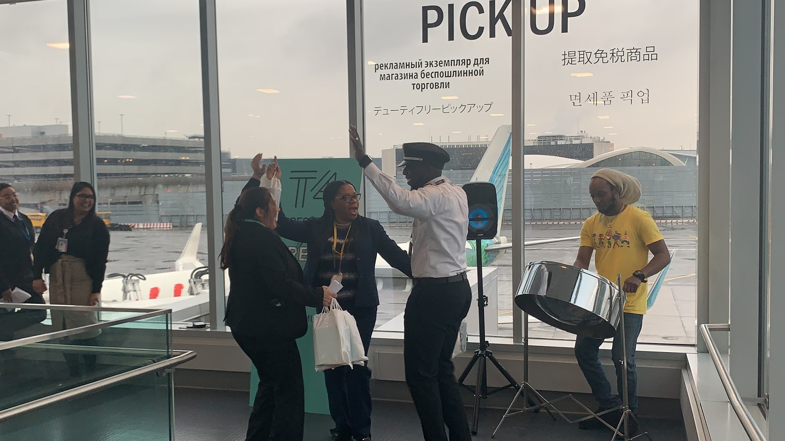
Kareem Thompson performs for T4 customers traveling with Caribbean Airlines as they board their flight.

“As the international gateway to New York City, we are proud to host cultural celebrations and festivals from around the world right here at our terminal,” said Roel Huinink, President and CEO of JFKIAT. “Our annual Carnival celebration with Caribbean Airlines is something we cherish, and we are thrilled to be a part of the many forms of this festival taking place around the world.”

About JFKIAT
JFK International Air Terminal, LLC. (JFKIAT) is the operator of Terminal 4 at John F. Kennedy International Airport, one of the most active air terminals in the New York area, serving 33 international and domestic airlines with an annual passenger volume of more than 21 million travelers in 2019. Terminal 4 is the first existing airport terminal in the U.S. to receive LEED Gold certification by the United States Green Building Council (USGBC) for operations and maintenance. The Terminal’s expansive Retail Lounge offers an unparalleled experience for travelers with a wide range of food and beverage and retail options, from chic to upscale and from convenience stores, to electronics, accessories and gifts. Terminal 4 was the first air terminal in North America operated by a private management company. JFKIAT’s managing member is Schiphol USA Inc., a U.S. affiliate of Royal Schiphol Group.

Visit us at http://www.jfkt4.nyc, like us on Instagram and follow us on Facebook and Twitter.

# # #

Contact: Patrice Rajacic
JFKIAT
(212) 402-3486
prajacic@marinopr.com

