FOR IMMEDIATE RELEASE

JFK AIRPORT’S TERMINAL 4 BECOMES FIRST NORTHEAST TERMINAL TO OFFER HIDDEN DISABILITIES LANYARDS

Terminal 4 will now provide sunflower lanyards to customers with non-obvious disabilities to subtly alert staff of required assistance

Queens, New York – February 24, 2020 – JFKIAT, the operator of Terminal 4 at John F. Kennedy International Airport, today announced its partnership with the U.K. based Sunflower Lanyard Scheme to offer customers traveling through the terminal a discreet way to alert employees that they may require additional assistance, support or time. T4 is the first airport terminal in the Northeast to offer these symbolic lanyards for customers with hidden disabilities, providing vital assistance to the passengers that walk through its doors each year who need additional assistance while traveling. The lanyards are available upon request from the T4 website.

The lanyard, which includes a simple sunflower image on a green background, was first introduced at Gatwick Airport in 2016 and since then, over two million lanyards have been provided to businesses and individuals worldwide.

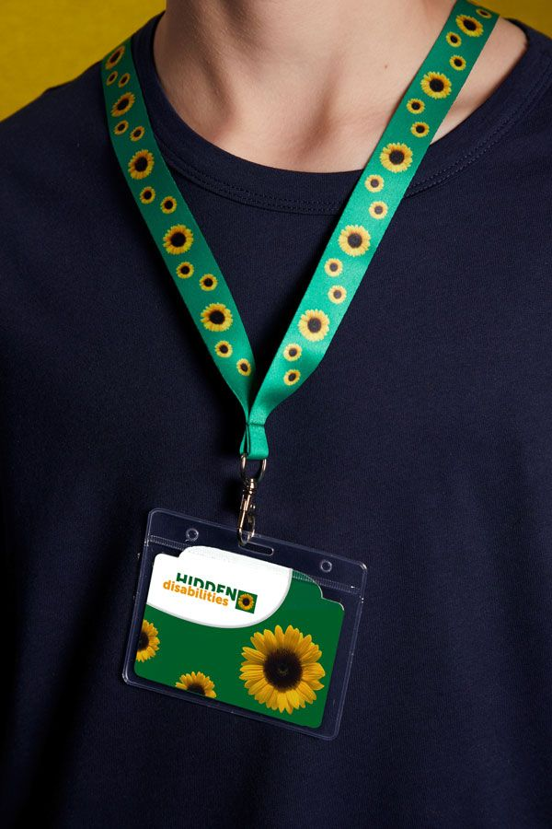
The lanyards will be available to customers traveling through the terminal upon request, providing a discreet way to alert employees that they may require additional assistance or time.

“At T4, we are always looking for ways to better serve our passengers, and we are proud to be the first air terminal in the Northeast to participate in the Hidden Disabilities Sunflower Lanyard Scheme,” said Roel Huinink, President and CEO of JFKIAT. “Through this partnership, we are excited to expand our accessibility services and help to make our customers’ journey as seamless and comfortable as possible.”

"We are thrilled to partner with T4 on this growing initiative to offer our lanyards for the first time in the Northeast US," said Paul White, CEO of Hidden Disabilities Sunflower Lanyard Scheme. "We believe this system will create a more comfortable and positive airport experience for people who have disabilities that might not be visible."

As one of the world’s most modern and efficient airport terminals, T4 works hard to foster an accessible terminal for all passengers. In addition to partnering with the Sunflower Lanyard Scheme, the terminal also previously became the first NYC airport terminal to offer Aira Access, providing passengers who are blind or have low vision with instant access to enhanced visual information and real-time service to navigate the terminal. T4 was also the first terminal in the NYC area to offer an arrivals accessibility meet and greet program for people with hidden disabilities. Upon request and pre-approved customs vetting, customers are met at the gate by a T4 employee, U.S. Customs and Border Protection Officer and their airline representative and expedited through Customs screening. Additionally, T4 was also the first airport terminal to offer Jetweels’ non-metallic, lightweight and ergonomic seat-equipped wheelchairs to improve the travel experience for passengers who need wheelchair assistance.

About JFKIAT
JFK International Air Terminal, LLC. (JFKIAT) is the operator of Terminal 4 at John F. Kennedy International Airport, one of the most active air terminals in the New York area, serving 33 international and domestic airlines with an annual passenger volume of more than 21 million travelers in 2019. Terminal 4 is the first existing airport terminal in the U.S. to receive LEED Gold certification by the United States Green Building Council (USGBC) for operations and maintenance. The Terminal’s expansive Retail Lounge offers an unparalleled experience for travelers with a wide range of food and beverage and retail options, from chic to upscale and from convenience stores, to electronics, accessories and gifts. Terminal 4 was the first air terminal in North America operated by a private management company. JFKIAT’s managing member is Schiphol USA Inc., a U.S. affiliate of Royal Schiphol Group.

Visit us at http://www.jfkt4.nyc, like us on Instagram and follow us on Facebook and Twitter.

About Hidden Disabilities Sunflower Lanyard Scheme
Living with a hidden disability can make daily life more demanding for many people, but it can be difficult for others to recognise, acknowledge or understand the challenges faced. The Hidden Disabilities Sunflower discreetly indicates to people including staff, colleagues and health professionals that the person wearing it (or someone with them) has a hidden disability and may need additional support, help or more time.

Visit us at http://www.hiddendisabilitiesstore.com/ and follow us on Facebook and Twitter.

# # #

Contact: Allie Novak
JFKIAT
(212) 402-3498
anovak@marinopr.com

