FOR IMMEDIATE RELEASE

XPRESCHECK PILOT PROGRAM FOR AIRPORT EMPLOYEES OPENS AT JFK AIRPORT’S TERMINAL 4, BECOMING THE FIRST AIRPORT COVID-19 SCREENING AND TESTING LOCATION IN THE U.S.

New testing site in Terminal 4 can provide 500 COVID-19 tests per day to JFK Airport workers

New York, NY – June 29, 2020 – Today JFKIAT, the operator of Terminal 4 at John F. Kennedy International Airport, in partnership with XpresSpa’s new brand XpresCheck and the Port Authority of New York and New Jersey, launched the first COVID-19 screening and testing location in a U.S. airport. The pilot program is now open to all JFK terminal employees, airline employees, and airport workers. The new XpresCheck has the capacity to screen up to 500 employees per day and will ensure that JFK workers have convenient access to testing at the airport.

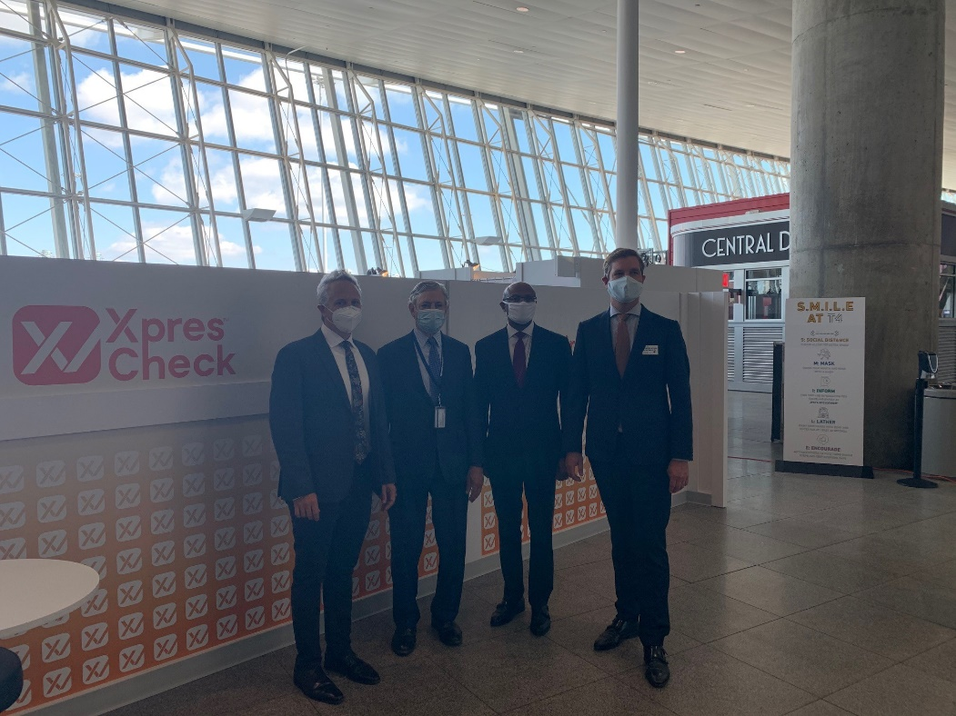
From left to right: Doug Satzman, CEO of XpresSpa; Rick Cotton, Port Authority Executive Director; Charles Everett, Jr., Port Authority Deputy Director, Aviation; Roel Huinink, President and CEO of JFKIAT.

The XpresCheck at JFK is a new modular site constructed in the Arrivals Hall at Terminal 4. The site holds nine separate testing rooms and provides the ability to conduct both COVID-19 testing as well as antibody testing. These services will be available to all airport employees, including airline employees, contractors and workers, concessionaires and their employees, TSA officers, and U.S. Customs and Border Protection agents. Both antibody testing and polymerase chain reaction (PCR) testing are available on-site, and the tests are sent to outside laboratories. All insurance plans are accepted outside of network and all information will remain private and HIPAA compliant.

“At JFKIAT, we have always looked for ways to better serve our employees, passengers, and front-line airport workers at Terminal 4, and in the wake of the COVID-19 pandemic, ensuring a safe environment is more important than ever before,” said Roel Huinink, President and CEO of JFKIAT. “We are very pleased to partner with XpresSpa and the Port Authority to launch the first air terminal testing site in the U.S.”

“The Port Authority is pleased to open the nation’s first COVID-19 and antibody testing facility for employees at JFK International Airport with JFTIAT and XpresSpa,” said Kevin O’Toole, Port Authority Chairman. “The agency will continue to enhance safety at its facilities by piloting the new technologies, programs, and policies needed to manage the impact of the coronavirus outbreak.”

“Safety and security are the Port Authority’s top priorities, and opening the new XpresCheck COVID-19 pilot program builds on measures the agency has taken to protect travelers and airport workers across the region,” said Rick Cotton, Port Authority Executive Director. “Today’s announcement is an important addition to our commitment to providing a safe facility for workers and travelers alike.”

"We are thrilled to launch our first pilot testing site at JFK Terminal 4, and we are hopeful that this will benefit airport workers,” said Doug Satzman, XpresSpa CEO. “Together with JFKIAT and the Port Authority, we will support the safety and health of front-line airport workers and travelers as New York’s recovery plan takes form.”

T4 at JFK International Airport is one of the most active air terminals in the New York area, serving 33 international and domestic airlines with an annual passenger volume of more than 21 million travelers in 2019. From the beginning of the COVID-19 outbreak, JFKIAT worked with the Port Authority to take immediate action and implemented key response initiatives focused on health, hygiene, safety and creating a contactless journey for employees and passengers. JFKIAT has also taken steps to prepare for a “new normal” as the aviation industry enters a post-COVID-19 landscape by collaborating closely with business and government agency partners to keep the terminal safe and secure, while winning back customer confidence as flights begin to resume.

About XpresSpa Group, Inc.
XpresSpa Group, Inc. (Nasdaq: XSPA) is a health and wellness holding company. XpresSpa Group’s core asset, XpresSpa, is a leading airport retailer of spa services and related health and wellness products, with 51 locations in 25 airports globally. XpresSpa offers services that are tailored specifically to the busy travel customer. XpresSpa is committed to providing exceptional customer experiences with its innovative premium spa services, as well as luxury travel products and accessories. XpresSpa provides almost one million services to customers per year at its locations in the United States, Netherlands, and the United Arab Emirates.
To learn more about XpresSpa, visit www.XpresSpa.com.

About JFKIAT
JFK International Air Terminal, LLC. (JFKIAT) is the operator of Terminal 4 at John F. Kennedy International Airport, one of the most active air terminals in the New York area, serving 33 international and domestic airlines with an annual passenger volume of more than 21 million travelers in 2019. Terminal 4 is the first existing airport terminal in the U.S. to receive LEED Gold certification by the United States Green Building Council (USGBC) for operations and maintenance. The Terminal’s expansive Retail Lounge offers an unparalleled experience for travelers with a wide range of food and beverage and retail options, from chic to upscale and from convenience stores, to electronics, accessories and gifts. Terminal 4 was the first air terminal in North America operated by a private management company. JFKIAT’s managing member is Schiphol USA Inc., a U.S. affiliate of Royal Schiphol Group.

Visit us at http://www.jfkt4.nyc, like us on Instagram and follow us on Facebook and Twitter.

# # #

Contact: Patrice Rajacic
JFKIAT
(212) 402-3486
prajacic@marinopr.com

