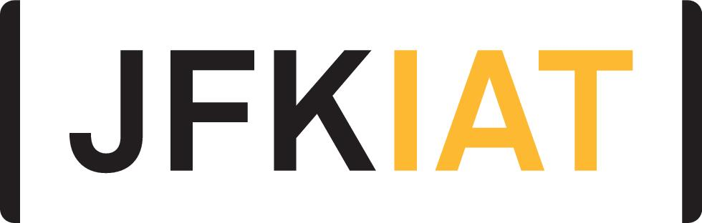
FOR IMMEDIATE RELEASE

JFK AIRPORT’S TERMINAL 4 IS WORLD’S FIRST AIR TERMINAL TO FEATURE GOOGLE ASSISTANT’S INTERPRETER MODE

JFKIAT partners with Google to bring real-time language translation to international travelers with the Google Assistant’s interpreter mode on Google Nest Hubs

Queens, New York – January 7, 2019 – JFKIAT, the operator of Terminal 4 at John F. Kennedy International Airport, is pleased to announce that it is the first airport terminal in the world to partner with Google to bring the Google Assistant’s interpreter mode real-time translation technology to customers traveling through T4.

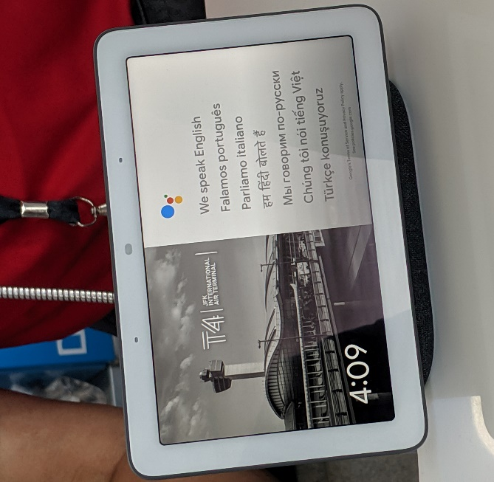

The Assistant’s interpreter mode, which can translate conversations across 29 languages in real-time, is now available on Google Nest Hubs placed at the Welcome Center in the Arrivals Hall as well as at the post-security information booth/help desk located in the retail lounge. Interpreter mode provides information agents at T4 with simpler, faster and more effective translation capabilities to help customers to locate luggage, navigate the terminal, find concessions, and locate ground transportation.

“T4 is widely regarded as the international gateway to New York City, with more than 21 million passengers traveling through the terminal each year – the majority of whom are international travelers,” said Roel Huinink, President and CEO of JFKIAT. “We are delighted to partner with Google to bring the Assistant’s innovative technology to our customers and make their experience more seamless and efficient as they travel through the terminal.”

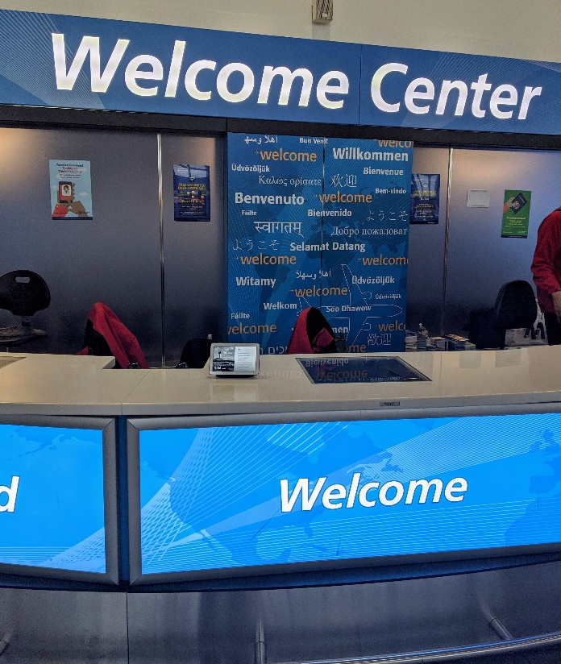

The introduction of the Google Assistant’s interpreter mode is JFKIAT’s latest move to bring innovative technology into the terminal to enhance the customer experience. Last year, JFKIAT introduced biometric boarding at several international gates throughout the terminal. T4 was also the first terminal in New York to offer Aira Access, providing passengers who are blind or have low vision with instant access to enhanced visual information and real-time service to navigate the terminal. In 2018, T4 launched a new Security Operations Center, integrating cutting edge technology to keep the 70,000 daily passengers and 13,000 employees safe and secure. The terminal also welcomed CLEAR, which allows travelers to verify their identity and get to their flights with the tap of a finger or blink of an eye.

About JFKIAT
JFK International Air Terminal, LLC. (JFKIAT) is the operator of Terminal 4 at John F. Kennedy International Airport, one of the most active air terminals in the New York area, serving 34 international and domestic airlines with an annual passenger volume of more than 21 million travelers in 2018. Terminal 4 is the first existing airport terminal in the U.S. to receive LEED Gold certification by the United States Green Building Council (USGBC) for operations and maintenance. The Terminal’s expansive Retail Lounge offers an unparalleled experience for travelers with a wide range of food and beverage and retail options, from chic to upscale and from convenience stores, to electronics, accessories and gifts. Terminal 4 was the first air terminal in North America operated by a private management company. JFKIAT’s managing member is Schiphol USA Inc., a U.S. affiliate of Royal Schiphol Group.

Visit us at http://www.jfkt4.nyc, like us on Facebook and follow us on Instagram and Twitter.
# # #

Contact: Patrice Kugler
JFKIAT
(212) 402-3486
pkugler@marinopr.com

