American Express Opens Flagship Centurion® Lounge at New York’s John F. Kennedy Airport

TWO-FLOOR LOUNGE IN TERMINAL 4 WILL CAPTURE THE ENERGY OF THE CITY WITH A CURATED MENU BY CHEF IGNACIO MATTOS, THE FIRST-EVER SPEAKEASY-STYLE BAR IN A CENTURION LOUNGE AND WELLNESS OFFERINGS FROM EQUINOX BODY LAB
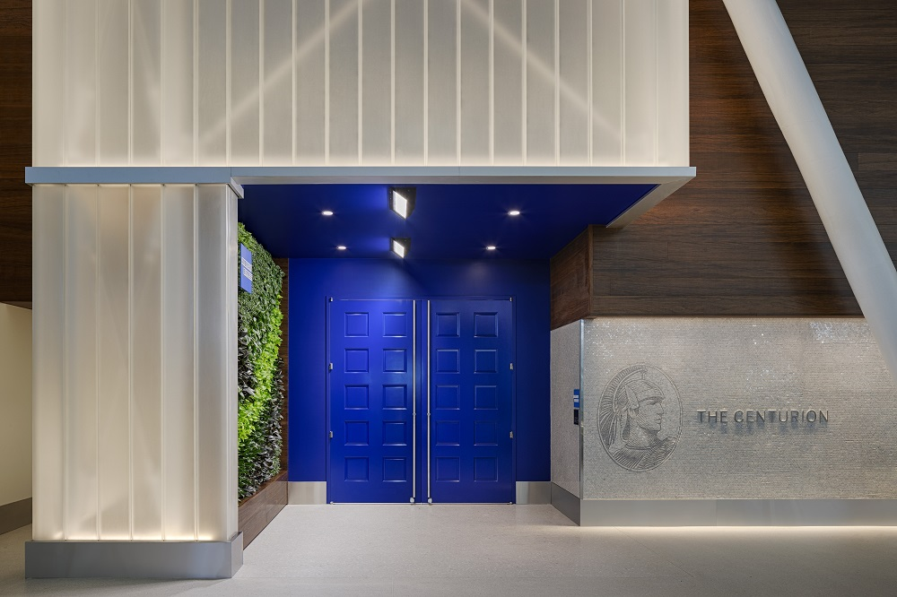
October 5, 2020 - Today, American Express (NYSE: AXP) announced its 13th Centurion Lounge will open at John F. Kennedy Airport (JFK)’s Terminal 4 in the coming days. With more than 15,000 square feet, the new space is the largest Centurion Lounge yet and the first with two guest floors.
“Our flagship Centurion Lounge at JFK is our fourth location to open in 2020 and reiterates our commitment to backing our Card Members whenever they may be ready to travel, while striving for a safe environment for all,” said Alexander Lee, Vice President of Travel Experiences and Benefits. “Like many of our customers we are proud to call New York City our home, and we are thrilled to have another lounge in our backyard. This new lounge will span two incredible floors and host a variety of amenities that bring New York City culture to life, plus floor-to-ceiling windows that offer sweeping views.”
Card Members visiting the Centurion Lounge at JFK will see new health-and-safety practices in place, as part of the “Centurion Lounge Commitment.” These new practices will be implemented across the lounge network and include socially distanced seating, reduced capacity, increased cleaning frequency, requirements to wear a face covering when entering the lounge, served food instead of buffets, and more.
The Centurion Lounge at JFK will feature American Express’ first-ever “1850” speakeasy bar¹, a reference to the year the company was founded, complete with cocktails developed by Centurion Lounge mixologist Jim Meehan, as well as an Equinox Body Lab wellness experience, a bespoke menu created by Executive Chef Ignacio Mattos, new design elements inspired by New York’s cultural landmarks and much more.
“We are proud that the new flagship American Express Centurion Lounge has made its home at Terminal 4,” said Roel Huinink, President & CEO of JFKIAT. “Its unique features, New York-inspired design and cuisine fit in well with our vision to create memorable travel experiences for our customers. In the wake of the COVID-19 pandemic, the health and safety of our passengers remains our highest priority, and we have ensured implementation of a wide range of safety initiatives throughout the terminal. We are excited for our customers to have another one-of-a-kind experience to enjoy when we see more people return to their travels.”
The opening of the lounge comes at a time when consumers are showing increased interest in domestic travel, according to American Express booking data – in the past three months there has been an upward trend in Card Member bookings to and from JFK airport. Plus, according to the Amex Trendex*, a trend report from American Express, among consumers who travel by plane, nearly three in five (58%) say they would be comfortable traveling by plane domestically within six months.
“1850” SPEAKEASY BAR BY JIM MEEHAN AND MENU BY IGNACIO MATTOS
The Centurion Lounge at JFK will introduce a new bar concept - the “1850” Speakeasy. Concealed behind a copper-paneled wall, this striking bar space evokes the Prohibition era through its design and sophisticated versions of classic cocktails, such as the espresso martini and boulevardier.
“So many legendary cocktails have come out of New York City over the years, based around a variety of different spirits,” says veteran New York cocktail pioneer Jim Meehan, creator of the “1850” speakeasy cocktail menu. “With New York classics meets travel as the main theme, I’ve come up with a rotating cocktail menu that is experiential in nature and gives a nod to some of the city’s greatest bars.” The “1850” space doubles as a café by day and will be in addition to the lounge’s main bar, which will serve a full cocktail menu featuring local spirits, also curated by Meehan.
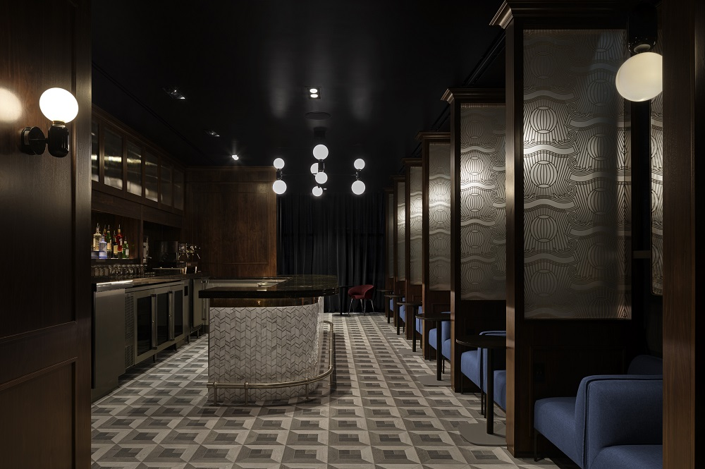
American Express continues to bring top-quality food experiences to its Centurion Lounges. The Centurion Lounge at JFK is proud to have Ignacio Mattos - a proud New Yorker and a four-time James Beard Award nominee - as the Executive Chef. Mattos has curated a menu that channels both the elegance and ethnic diversity of the city’s vibrant restaurant scene, with signature dishes including a caciocavallo and egg sandwich with tomato marmalade, fennel salad with castelvetrano olives and provolone and steak with romesco and taleggio sauce. When the lounge opens, the food will all be served by American Express representatives, instead of buffet-style, as part of the new health and safety practices for all Centurion Lounges.
“For the JFK Centurion Lounge menu, I focused on adapting my restaurant cuisine in a way that makes sense for the lounge space and guests’ preferences,” said Mattos, who received a Michelin star last year for Estela, his celebrated restaurant in downtown Manhattan. “What I’ve created is a menu that’s refined, eclectic, exciting and elegant, representing what I love most about New York City and its diverse communities.”
The JFK lounge will also feature some local wines from New York, selected by Centurion Lounge wine director Anthony Giglio, and coffee from Irving Farm New York.
ELEVATED NEW YORK-INSPIRED DESIGN
Design continues to play an important role in creating a relaxing and welcoming experience for Card Members within the Centurion Lounges. The Centurion Lounge at JFK pays homage to New York City’s past and present, with unique touches throughout the space. Greeting guests as they approach the lounge is a handmade, custom mosaic art mural sourced from SICIS, the renowned mosaic art factory, developed with the Sicis North American Bronx-based team, as a nod to New York City subway murals.
Throughout the lounge, vintage New York City taxi meters, architectural renderings of Manhattan landmarks and other local artifacts are showcased on walls and shelves. The lounge will also offer six unique rooms, each influenced by a different New York City landmark or iconic design period. These rooms will maximize the sense of discovery visitors will feel while walking through the lounge and they are named for the year they were inspired by. All seating arrangements have also been configured to allow for social distancing and enable Card Members to have an enjoyable, and productive, pre-flight experience. Membership Service Professionals will help guide Card Members to available seating when they arrive.
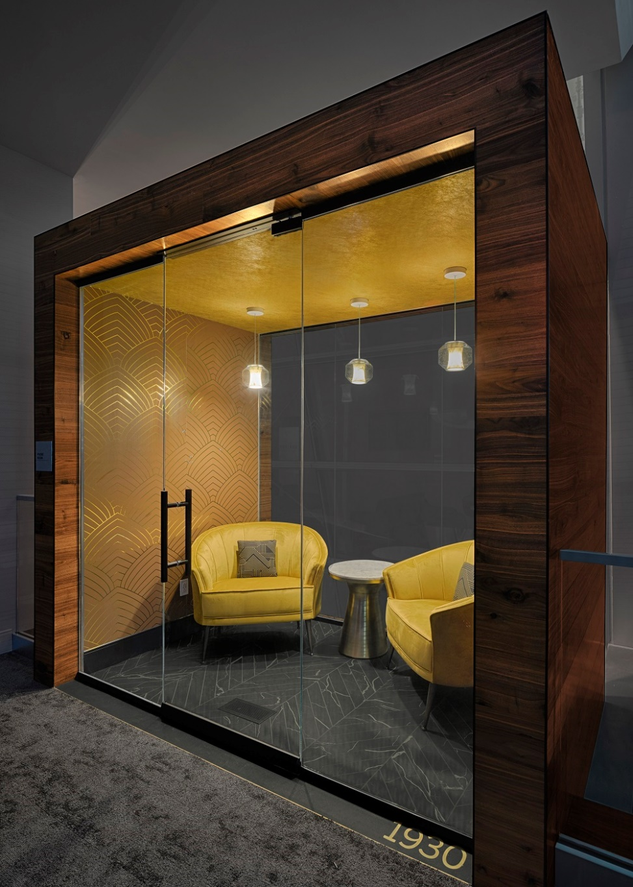
THE ULTIMATE PRE-FLIGHT EXPERIENCE BY EQUINOX
In partnership with high-performance lifestyle leader Equinox, the Centurion Lounge at JFK will debut the Equinox Body Lab, a first-of-its kind regenerative destination designed specifically for an indulgent pre-flight experience. The Equinox Body Lab, normally only accessible within Equinox clubs, will offer performance-driven restorative therapies including custom, self-guided meditation and stretching sessions using the Variis by Equinox app, a vibro-acoustic chair to help fliers relax before takeoff, and more. When the lounge opens, these sessions will be offered to individuals, in a self-led format to prioritize health and safety.
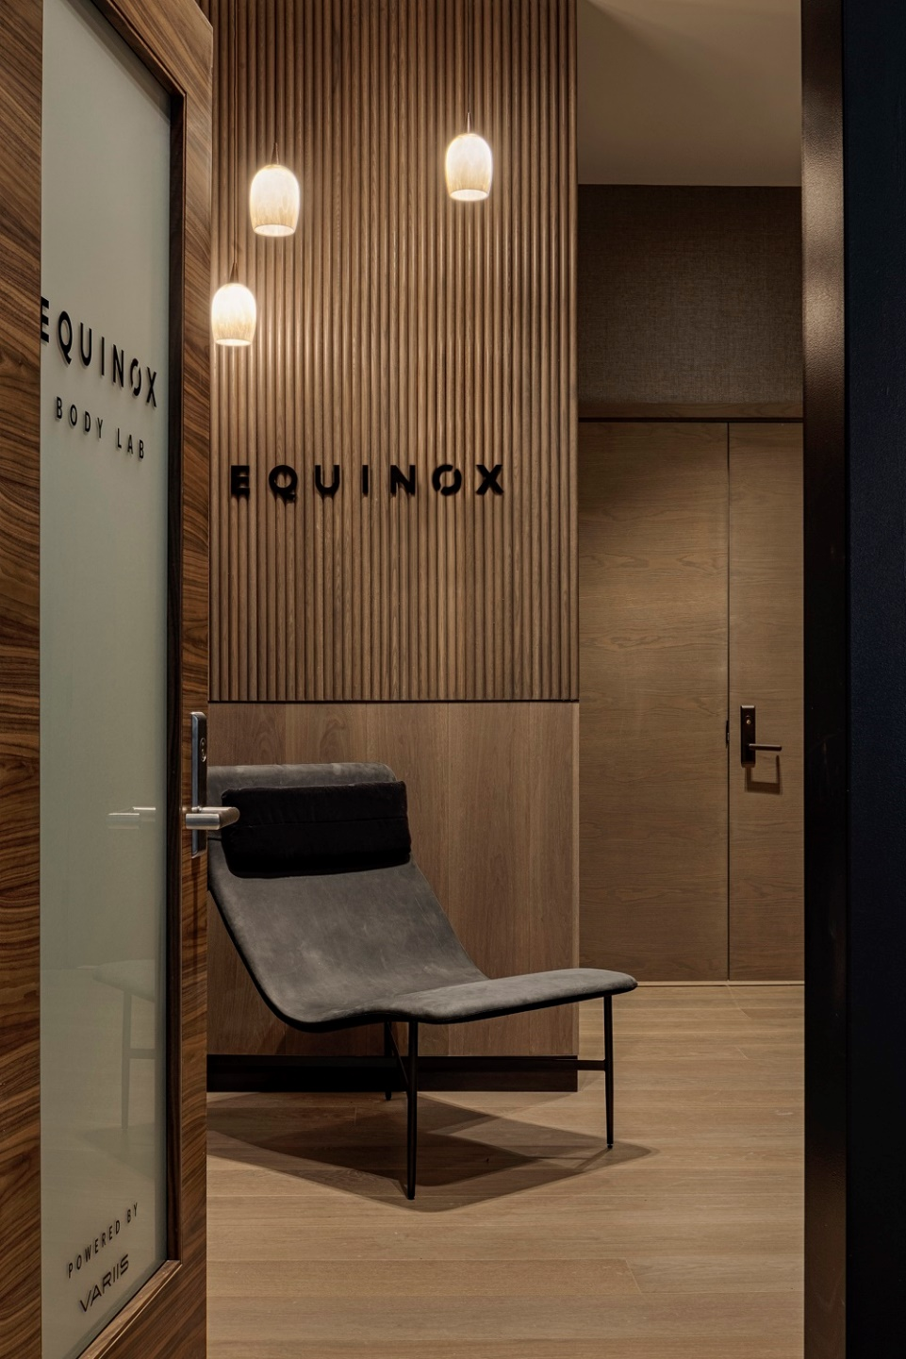
The American Express Global Lounge Collection® provides Platinum Card Members, Centurion Members and Delta SkyMiles® Reserve Card Members with places to relax and recharge while traveling the globe.
Card Members can find a lounge at the Global Lounge Collection website or by using the American Express® App. They can also check into select Centurion Lounges through the mobile check-in tool within the American Express® App.
Lounge access is just one of the many ways American Express backs Card Members’ journeys, when they’re ready to travel, with additional offerings available for Platinum Card and Centurion Members through American Express Travel and their Concierge, including access to the Fine Hotels + Resorts program,The Hotel Collection,International Airline Program,The Global Dining Collection, and more.
*Amex Trendex Methodology:
This online poll was conducted by Morning Consult between September 17-18, 2020 among a national sample of 2,000 general population travelers with a household income of at least $70K and defined as adults (18+) who traveled by air at least once in 2019. Results from the survey have a margin of error of plus or minus 2 percentage points.
ABOUT AMERICAN EXPRESS
American Express is a globally integrated payments company, providing customers with access to products, insights and experiences that enrich lives and build business success. Learn more at americanexpress.com and connect with us on facebook.com/americanexpress, instagram.com/americanexpress, linkedin.com/company/american-express, twitter.com/americanexpress, and youtube.com/americanexpress.
Key links to products, services and corporate responsibility information: charge and credit cards, business credit cards, travel services, gift cards, prepaid cards, merchant services, Accertify, InAuth, corporate card, business travel, and corporate responsibility.
ABOUT THE CENTURION LOUNGE
The Centurion Lounge is the signature lounge program within the broader American Express Global Lounge Collection, which includes access to American Express Centurion Lounges, international American Express lounges, Delta Sky Club® for Card Members flying on Delta, Priority PassTM Select Lounges upon enrollment, Airspace Lounges, MAG U.S. Escape Lounges and Plaza Premium Lounges--a total of more than 1,300 lounges across 140 countries and counting.
In addition to The Centurion Lounge at John F. Kennedy Airport, American Express is working towards opening its newest lounge locations later this year in London’s Heathrow Airport and Denver International Airport.
Access to The Centurion Lounge is complementary and exclusive for Platinum Card Members, Centurion Members and Delta Skymiles® Reserve Card Members. Platinum Card Members may enter with up to two travel companions at no additional charge. Centurion Members may enter with their immediate family or up to two travel companions. Platinum and Centurion Card Members may purchase access to The Centurion Lounge for additional guests for $50 each guest. Delta SkyMiles® Reserve Card Members may bring up to two guests at a per-visit rate of $50 per person, per location.²
ABOUT JFK International Air Terminal, LLC. (JFKIAT)
JFK International Air Terminal, LLC. (JFKIAT) is the operator of Terminal 4 at John F. Kennedy International Airport, one of the most active air terminals in the New York area, serving 33 international and domestic airlines with an annual passenger volume of more than 21 million travelers in 2019. Terminal 4 is the first existing airport terminal in the U.S. to receive LEED Gold certification by the United States Green Building Council (USGBC) for operations and maintenance. The Terminal’s expansive Retail Lounge offers an unparalleled experience for travelers with a wide range of food and beverage and retail options, from chic to upscale and from convenience stores, to electronics, accessories and gifts. Terminal 4 was the first air terminal in North America operated by a private management company. JFKIAT’s managing member is Schiphol USA Inc., a U.S. affiliate of Royal Schiphol Group.
¹Must be of legal drinking age to consume alcoholic beverages. Please drink responsibly.
²Subject to availability/capacity.
CONTACTS:
AMERICAN EXPRESS
Margot Leeds
Margot.Leeds@aexp.com

