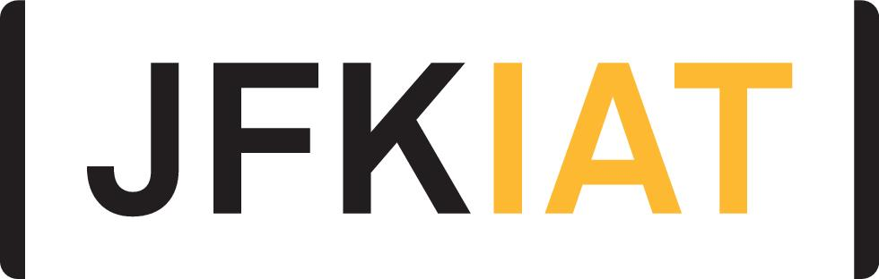
FOR IMMEDIATE RELEASE
JFK AIRPORT’S TERMINAL 4 HOSTS BLUE CAMPAIGN EVENT
WITH THE DEPARTMENT OF HOMELAND SECURITY
JFKIAT participated in DHS’ #WearBlueDay to raise awareness for human trafficking

Queens, New York – January 8, 2020 – JFKIAT, the operator of Terminal 4 at John F. Kennedy International Airport, participated in the Department of Homeland Security’s (DHS) Blue Campaign, #WearBlueDay, to spread awareness for human trafficking with an event in the terminal.
Ahead of National Human Trafficking Awareness Day on January 11, JFKIAT and DHS partnered to raise awareness on human trafficking and generate an online conversation about the crime. Agents from Homeland Security Investigations (HSI), an investigative arm of DHS, informed customers and employees passing through the terminal from 12:00 – 5:00 PM at a table near the Retail Lounge Information Desk about #WearBlueDay, the campaign’s largest awareness initiative that invites people from all over the country to participate by wearing a piece of blue clothing, taking a picture with other participants, and posting it on social media and tagging @DHSBlueCampaign or using the hashtag.
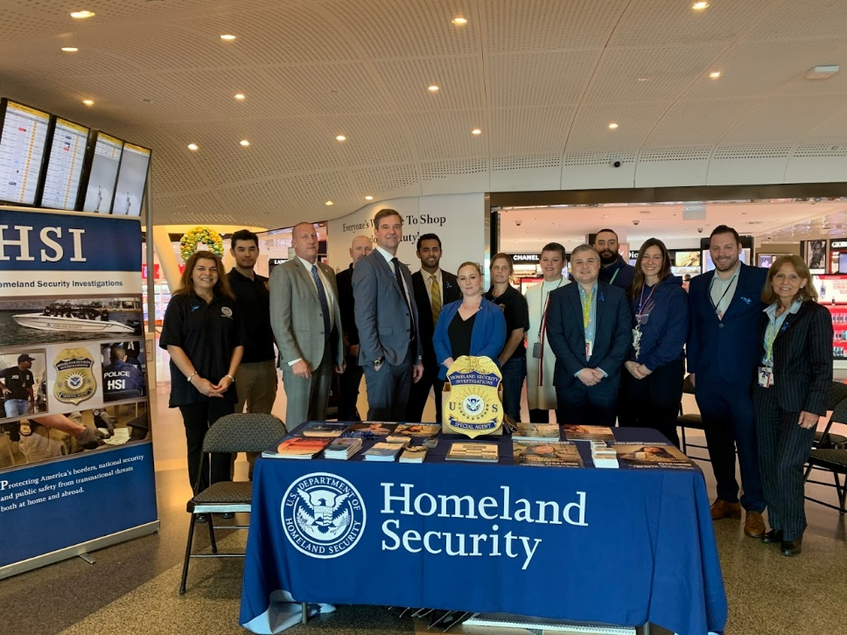
“JFKIAT is proud to bring the Department of Homeland Security’s #WearBlueDay to T4,” said Roel Huinink, President & CEO of JFKIAT. “As a terminal dedicated to international travel that hosts over 21 million passengers each year, T4 is committed to educating and preparing our employees to identify victims of human trafficking and partner with DHS to limit this crime. Creating a safe and secure environment at T4 is our highest priority and we are excited to partner with DHS now and in the future on activations that can benefit our passengers.”
“Homeland Security Investigations is excited to work with JFKIAT to raise awareness around National Human Trafficking Awareness Day,” said Peter C. Fitzhugh, special agent in charge for HSI New York. “We are appreciative of JFKIAT’s willingness to participate in an important campaign and hope to work together to heighten conversations with them around #WearBlueDay and other significant causes in the future.”

About JFKIAT
JFK International Air Terminal, LLC. (JFKIAT) is the operator of Terminal 4 at John F. Kennedy International Airport, one of the most active air terminals in the New York area, serving 34 international and domestic airlines with an annual passenger volume of more than 21 million travelers in 2018. Terminal 4 is the first existing airport terminal in the U.S. to receive LEED Gold certification by the United States Green Building Council (USGBC) for operations and maintenance. The Terminal’s expansive Retail Lounge offers an unparalleled experience for travelers with a wide range of food and beverage and retail options, from chic to upscale and from convenience stores, to electronics, accessories and gifts. Terminal 4 was the first air terminal in North America operated by a private management company. JFKIAT’s managing member is Schiphol USA Inc., a U.S. affiliate of Royal Schiphol Group.
Visit us at http://www.jfkt4.nyc, like us on Instagram and follow us on Facebook and Twitter.
# # #

Contact: Patrice Kugler
JFKIAT
(212) 402-3486
pkugler@marinopr.com

