FOR IMMEDIATE RELEASE

JFK T4 LAUNCHES LIFE-SIZED COLORING BOOK EXPERIENCE
FOR TRAVELERS

The interactive experience will promote travel exploration through illustration

Queens, New York – June 14, 2021 – JFKIAT, the operator of Terminal 4 at John F. Kennedy International Airport, today announced its latest interactive experience for travelers, “Where Will You Go Next?” This pop-up experience invites passengers into the page of a life-sized coloring book, calling for participants to tap into their creativity and take part in creating the 35-foot mural.

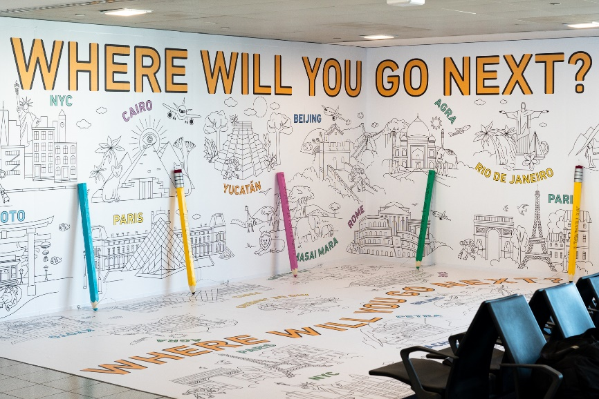

As the world recovers from the pandemic, this interactive installation will engage passengers in the globetrotting adventures that await, offering a glimpse of the magic of traveling to wherever they desire. Destinations include the New 7 World Wonders: Machu Picchu, The Great Wall of China, Chichén Itzá, the ancient city of Petra in Jordan, Christ the Redeemer in Rio de Janeiro, the Colosseum, and the Taj Mahal. Monumental locations like New York City’s Statue of Liberty, the Eiffel Tower, the Louvre, and the Fushimi Inari Shrine of Kyoto will also be featured. At the end of this artistic journey, passengers will be left wanderlust wondering ’where will I go next?’ as they continue to their next destination with a coloring book souvenir from T4.

“This is truly a special installation that brings to life the joys of traveling around the world, which is something our passengers have been missing this past year,” said Roel Huinink, President & CEO of JFKIAT. “As we continue to see increases in passenger volumes, this pop-up experience will celebrate the beginning of new adventures among travelers. This will be a memorable experience for people of all ages, and I encourage everyone to visit ‘Where Will you Go Next?’ and enjoy the creativity and detail that went into this life-size coloring book.”

The installation is located across from Gate B26 in T4, and it will be available to the public throughout the summer.

About JFKIAT
JFK International Air Terminal, LLC. (JFKIAT) is the operator of Terminal 4 at John F. Kennedy International Airport, one of the most active air terminals in the New York area, serving 33 international and domestic airlines with an annual passenger volume of more than 21 million travelers in 2019. Terminal 4 is the first existing airport terminal in the U.S. to receive LEED Gold certification by the United States Green Building Council (USGBC) for operations and maintenance. The Terminal’s expansive Retail Lounge offers an unparalleled experience for travelers with a wide range of food and beverage and retail options, from chic to upscale and from convenience stores, to electronics, accessories and gifts. Terminal 4 was the first air terminal in North America operated by a private management company. JFKIAT’s managing member is Schiphol USA Inc., a U.S. affiliate of Royal Schiphol Group.

Visit us at http://www.jfkt4.nyc, like us on Instagram and follow us on Facebook and Twitter.

# # #

Contact: Patrice Rajacic
JFKIAT
(212) 402-3486
prajacic@marinopr.com

