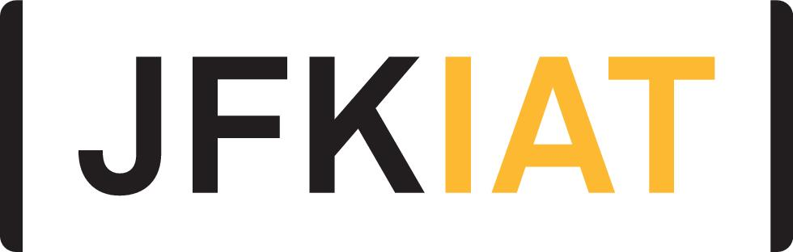
FOR IMMEDIATE RELEASE

JFK AIRPORT’S TERMINAL 4 HOSTS HOLIDAY CONCERT BY LOCAL QUEENS MIDDLE SCHOOL BAND

JFKIAT advances its 4GOOD philanthropy program through a special partnership with
M.S. 226

Queens, New York – December 26, 2019 – JFKIAT, the operator of Terminal 4 at John F. Kennedy International Airport, recently hosted the M.S. 226 – Virgil I. Grissom band to play a special concert for those traveling through the terminal during the holiday season.

Customers traveling through the Arrivals Hall were given a warm welcome into New York City and treated to live holiday songs played by the talented band of 20 students. M.S. 226 Principal Rushell White and JFKIAT President and CEO Roel Huinink joined the students.

The ongoing partnership with M.S. 226 is a part of JFKIAT’s broader corporate philanthropy program, 4GOOD, which aims to promote educational and professional success in the community. JFKIAT has previously donated school supplies, computers, cameras to the school’s photography program, and displayed the M.S. 226 students’ artwork in the Arrivals Hall at Terminal 4. Earlier this year, JFKIAT also participated in a Young Women’s Leadership panel to discuss career paths with students.

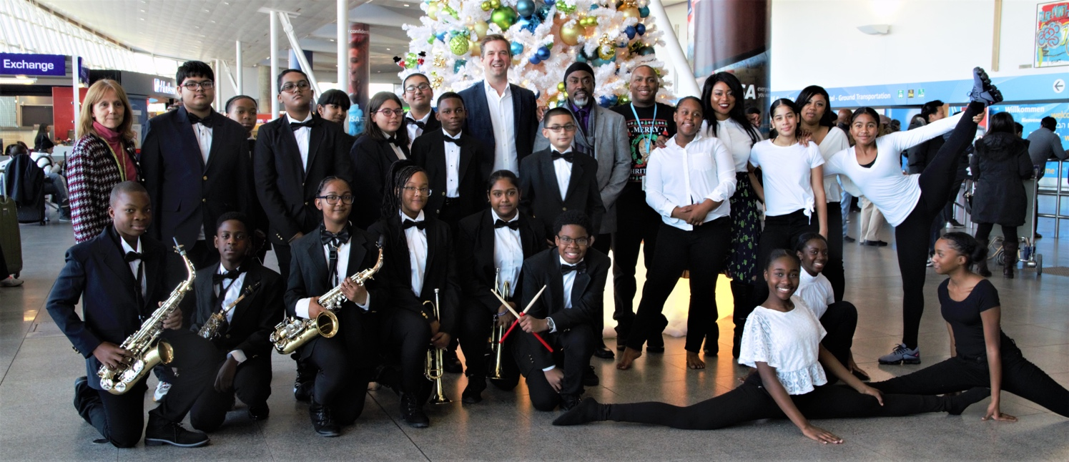

“At JFKIAT, we are proud to showcase the budding talent of these incredible students in our community as they bring holiday cheer to our customers,” said Roel Huinink, JFKIAT President and CEO. “Our partnership with M.S. 226 through our 4GOOD program is one that we cherish, and we look forward to advancing this relationship with additional events in the new year.”

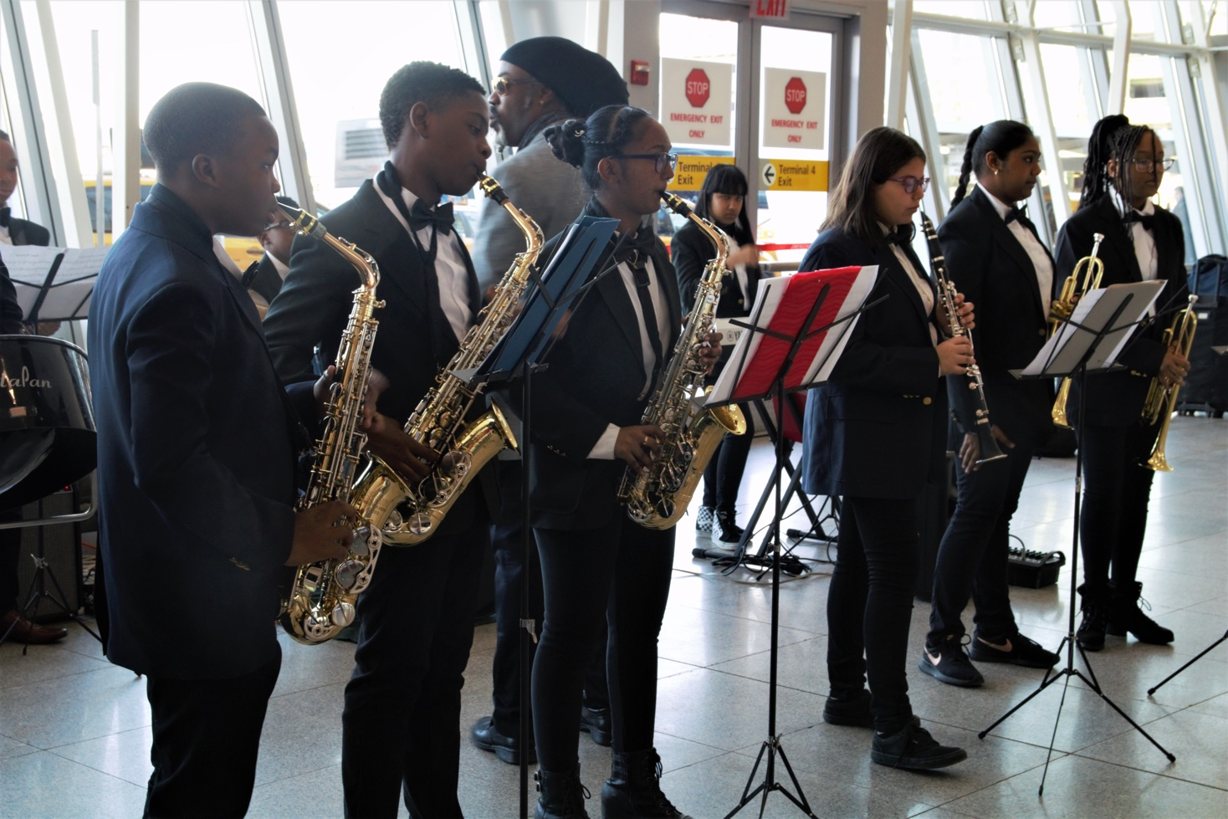

“We are grateful for our partnership with JFKIAT, and the opportunity for our students to perform a holiday show in the terminal,” said Rushell White, Principal of M.S. 226. “Being able to take our students out of the classroom and into the community helps them excel, and we are excited to continue making events like these possible with JFKIAT.”

About JFKIAT
JFK International Air Terminal, LLC. (JFKIAT) is the operator of Terminal 4 at John F. Kennedy International Airport, one of the most active air terminals in the New York area, serving 34 international and domestic airlines with an annual passenger volume of more than 21 million travelers in 2018. Terminal 4 is the first existing airport terminal in the U.S. to receive LEED Gold certification by the United States Green Building Council (USGBC) for operations and maintenance. The Terminal’s expansive Retail Lounge offers an unparalleled experience for travelers with a wide range of food and beverage and retail options, from chic to upscale and from convenience stores, to electronics, accessories and gifts. Terminal 4 was the first air terminal in North America operated by a private management company. JFKIAT’s managing member is Schiphol USA Inc., a U.S. affiliate of Royal Schiphol Group.

Visit us at http://www.jfkt4.nyc, like us on Facebook and follow us on Instagram and Twitter.
# # #

Contact: Patrice Kugler
JFKIAT
(212) 402-3486
pkugler@marinopr.com

